**BABEŞ-BOLYAI UNIVERSITY CLUJ-NAPOCA**

**FACULTY OF MATHEMATICS AND COMPUTER SCIENCE**

**SPECIALIZATION COMPUTER SCIENCE IN GERMAN**

**DIPLOMA THESIS**

**Vehicle management using OCR for extracting data from documents**

**Supervisor**

**Lecturer Diana Cristea, PhD**

**Author**

**Cîrstea Ștefan-Daniel**

**2022**

**BABEŞ-BOLYAI UNIVERSITÄT CLUJ-NAPOCA**

**FAKULTÄT FÜR MATHEMATIK UND INFORMATIK**

**INFORMATIK IN DEUTSCHER SPRACHE**

**BACHELORARBEIT**

**Fahrzeugverwaltung mit OCR zum Extrahieren von Daten aus Dokumenten**

**Betreuer**

**Lektor Dr. Cristea Diana**

**Eingereicht von**

**Cîrstea Ștefan-Daniel**

**2022**

**UNIVERSITATEA BABEŞ-BOLYAI CLUJ-NAPOCA**

**FACULTATEA DE MATEMATICǍ ŞI INFORMATICǍ**

**SPECIALIZAREA INFORMATICĂ GERMANĂ**

**LUCRARE DE LICENŢĂ**

**Managementul vehiculelor folosind OCR pentru a extrage datele din documente**

**Conducător ştiinţific**

**Lect. Univ. Dr. Cristea Diana**

**Absolvent**

**Cîrstea Ștefan-Daniel**

**2022**

**Abstract**

Time becomes more and more an exhaustible resource. Today, everyone has daily tasks planned, moreover, there are other activities that comes by circumstances. That active lifestyle grows the possibility to forget something, especially when is something that need to me done in a month or even a year or two. This Bachelor Thesis presents an option that remains users about their vehicle related activities that take place on longer periods of time. Moreover, focus is on saving users time by offering the possibility to automatically extract the data from document images using Optical Character Recognition (OCR). Technologies used for OCR process are described in Chapter 3. In Chapter 4.1, this thesis describes .Net 6 Framework, the technology used for the application’s business logic. Chapter 4.2 is related to previous chapter because it offers persistence to the applications and convers information about relational databases and MS SQL. In Chapter 4.3, we introduce technology we used for creating the user interface, namely React.JS. Next, this Bachelor Thesis focuses more on the application part. Next chapters analyze how all technologies described are put into practice. In chapter 5.1, the focus is on application structure and deployment options. This chapter describes how application OCR algorithm, server-side, database and client-side technologies are linked one to another and the option used for deploying the entire assembly. Next, Chapter 5.2 describes the steps required for extracting information from images using OCR. In Chapter 5.3, we discus about server-side solution, project structure and security measures. Next chapter that describes the applications is Chapter 5.4 which covers the clients-side project. In chapter 5.6, we offer an idea about how this application can be used and which are the main features. In the final part of the thesis, we describe the achievements of the application and future options for next feature and improving existing ones.

Table of Contents

1. Introduction 1

2. Scope and motivation 3

3. Optical Character Recognition (OCR) 4

4. Web applications 7

4.1. Server-side technologies 9

4.2. Relational Database 11

4.3. Client-side technologies 12

4.3.1. React.JS 12

4.3.2. Redux 14

5. Application 15

5.1. Application structure and deployment schema 15

5.2. Optical Character Recognition (OCR) 16

5.2.1. Preprocessing 16

5.2.2. Text extraction 17

5.2.3. Postprocessing 17

5.2.4. Exposing 18

5.3. Server-side 18

5.3.1. Structure 18

5.3.2. Authentication & Authorization 19

5.3.3. Vehicle permission 20

5.4. Client-side 24

5.4.1. Structure 24

5.4.2. Authentication context 24

5.5. Database structure 26

5.6. User manual 29

6. Final words 32

7. References 33

# 1. Introduction

Today’s life is quite active, a lot of people are driving from a place to another, everyone has daily task to do, students, employers, teachers, CEOs and even retirees. Having activity every day whether it involves leaving home or not increase the possibility to forget something especially when it is an activity you should do once in a year or two as technical vehicle inspection or insurance. These are moments when a quick reminder can be great and can save you from getting a fine or even worse.

Figure 1 - My Vehicle Management application logo

My Vehicle Management (MvManagement) is one application that stores vehicle information, driver related documents and reminds its users before their documents expire. People today are quite busy and get bored very fast especially when they need to fill up a lot of forms with exact information that maybe they should look for before. Therefore, MvManagement considered implementing automatic information extraction from documents so that the user can quickly store it in the application. Moreover, taking into count that the fuel price is raised the application offers their user the possibility to keep track of their fuel spendings. Application is designed for drivers especially for peoples whose life are quite busy and have a lot of activities every day. We consider that the user that will benefit of all the application features is someone from a technical domain that like being informed by their vehicle status or a company having more vehicles that can be tracked using MvManagement application.

From a technical perspective the MvManagement application uses one of the newest technologies available. Graphical user interface is designed using React.JS, a powerful JavaScript framework. The business logic is developed using .NET 6 (LTS) which is the latest version of .NET released by Microsoft in November 2021 together with the MS SQL database for data persistence. For the key feature of the application, document information extraction, the solution is implemented using Tesseract OCR engine developed and strongly maintained by Google. To get the most of these relatively new technologies, documentation was mandatory. The inspiration sources come from books, scientific articles, technical documentation, GitHub repositories and conferences.

MvManagement aim to help people keep track of their vehicle related documents and not only that without taking too much of their time. Using this application users are aware of their vehicle related documents expiring date, personal documents expiring date, their spending related vehicles managed in application and have statistics about their vehicles.

Next pages will cover up technologies considered and why they are the best option for this particular case, how is the applications build in details, what are the key features and how can they be used.

# 2. Scope and motivation

Today, there are more applications that help people remember things, and many ways to store data about your daily activities. Some deadlines are easy to be forgotten especially when it takes more than one or two months to take place. Because of that, we had chosen to create an application which scope is to help people manage all their vehicle related information.

Managing vehicles using mobile or web-based applications is not a new idea and it has been done before, an example of this kind is MOVCAR [1]. Because we know that time is very important in our days, anyone have more to do every day and because I am a driver, I like driving and I know I will always be a driver, our application is looking to help people manage their vehicles. Moreover, is looking to help them by extracting data from their documents.

|  |  |  |  |  |  |  |  |
| --- | --- | --- | --- | --- | --- | --- | --- |
| Application / Features | Deadline reminder | Fleet management | Fuel  Management | Data  extraction | Web  solution | Personal documents | Cloud  solution |
| MvManagement | X | X | X | X | X | X | X |
| MOVCAR | X | X | X |  | X |  | X |
| MyCar | X |  |  |  |  |  | X |
| Car Alert | X |  |  |  |  |  |  |

There are more other applications that remind people of their periodical mandatory activities or documents that need to be done in order to be safe as a driver. Table 1 shows a comparison between some of these apps and the app developed by us.

Table 1 - Applications comparison

Besides the vehicle documents is very important to keep track of your personal documents as driving license, for example in Romania expires at 10 years intervals or passport or any other traveling documents. With this idea in mind MvManagement covers this feature.

Taking into count that a lot of drivers stores in their phone a photo of their documents in case they forget the originals at home or from any other reason we considered that uploading the image for document data extraction will be the preferred way to go for most of the users.

# 3. Optical Character Recognition (OCR)

Optical Character Recognition or known as OCR represents a technology used for recognizing and extracting text within a digital source as images and converting information into a machine-readable form in order to use it for data processing. The OCR principle seem to be straightforward, but its implementation may not be that simple because of the variety of fonts and letter spacing formatting. Even then the most difficult job for OCR systems remains recognizing and extracting handwritten text because there are very few writing styles that match, and most offend it will be different.

The process of OCR involves three main objectives that are reached using a series of steps. These objectives are pre-processing of the image, character recognition and post-processing the output. As expected, the first step of OCR is scanning the document. By scanning we can ensure that the document is well aligned and fit a size pattern. This method encourages the correctness and efficiency of text extraction. Preparing the image, this step is focused on removing imperfections from the image. This step aims to create a focus on characters and to sharpen them in order to make text clear. The next step is designed to make the document as simple as possible, and it can be called Binarization. Binarization process states in redefining the image document so that it is bi-component build, containing only black and white colors. Black and dark areas are considered to be the text zone and the same time, the white and light areas are considered background and are ignored, that technique encourage optimal recognition of the characters. Another phase and the one for which all pre-processing of the image steps were needed is recognizing characters phase. In this phase, the black areas are processed in order to recognize letters or digits. Mainly, OCR focuses on one character or on a block of text. Pattern recognition and feature detection represent the two algorithms mainly used for recognizing characters. Pattern recognition involves training the OCR software in a way that it can learn the font and format. The software is then used for comparing and recognizing characters in the scanned document. Through Feature detection algorithm the OCR software recognize letters and digits by their particularities in the scanned document. Features in this context can include number of angled lines, curves or crossed lines. A very common use of OCR is vehicle registration plate recognition and now it is implemented in traffic monitoring camaras. In Figure 2 - OCR Example from PaddleOCR is showed an example Graphical user interface, application, website
found on GitHub at PaddleOCR [2] is showed.

Figure 2 - OCR Example from PaddleOCR [20]

The very specific part of recognizing characters is called OCR Engine. OCR is not a very new technology so there are more OCR Engines available and each of those have advantages and disadvantages. For using some OCR Engines paying a tax is required and taking based on accuracy of the engine the cost can be higher. The most used solution is Google’s Tesseract which can be the best option by the fact that it is free, because it is an open-source OCR Engine. The result of this engine maybe is not as accurate as the ones from ABBY FineReader which is a paid option.

Tesseract is the option for this project. According to OCR with OpenCV, Tesseract, and Python book written by Adrian Rosebrock [3] Tesseract was at first a closed source software developed by Hewlett-Packard (HP) Labs in the 1980s. Then it became an open source in 2005 and in 2006 it started to be sponsored by Google. Today, in development Tesseract is mainly used with Python. This combination of Python and Tesseract is encouraged by the tool developed by Matthias A Lee [4], who made the python package that interfaces with the tesseract command line binary.

To achieve a better accuracy for OCR a good practice is to have some operation to prepare the image for the OCR. All these operations can be taken as a step of the OCR process and named pre-processing. The steps in pre-processing part are deferent, but all follows the same principle of computer vison and has as scope clearing the image. A very used library for computer vison and image processing is the OpenCV [5] python library. Not all the images are the same, and that is why not all the pre-processing tasks are the same.

An example of why the pre-processing is important is showed in the figure delivered by OCR with OpenCV, Tesseract, and Python book, Figure 3. Tesseract without pre-processing, showed in the top left corner the engine recognizes the text as being 12:14. This inaccurate result is because of the unclear background from the original image. This tesseract run is also showed in the bottom image from Figure 3. After processing, the image resulted is shown in the top right image and for this, the Tesseract result is 12-14. In conclusion, the pre-processing step is very important when the background has more shapes that can disturb the text reading.

Figure - Results with and without pre-processing [3]

Tesseract is a local software that can be used just by the computer user. In order to make our OCR programs that are built in python useful, they should be accessed also by someone else. These days the most commonly tools that are used for sharing code through the internet are APIs. This APIs endpoint can be also achieved with Python and there are some libraries that offer the possibility to create those APIs. One relatively new option is FastAPI [6] which had the first release in 2018. FastAPI is a tool the offers the possibility to expose APIs fast and without any other complicated setup. The advantages of FastAPI in terms of OCR sharing are that it is fast to setup, easy to use and does not come with a graphical interface which in this case is not needed. For example, FastAPI does not include a mandatory graphical interface, so the project structure is cleaner and offers the possibility for the developer to choose whether they want a graphical interface or not.

# 4. Web applications

Web applications are developed software that runs on a web server and can be remotely accessed from other devices through a browser interface. This kind of applications are designed for a variety of scopes from online calculator to web mailing applications, e-commerce shops and even more complex applications. They are usually built from three very important and decoupled parts, frontend or client-side, backend or server-side and database. Client-side represents all the graphical interfaces, directly, what the user sees. Backend is the part in charge of creating the logic of the application and the mediator between the frontend and the database, basically its scope is processing data and sending it to the client-side. Database part is the one which is storing the data and is responsible of the correctness of it.

Web applications do not need to be downloaded, in order to run they need a web server, application server host the logic and a database. Web servers are responsible for hosting the client-side of the application and for managing the request that comes from the client. Application server completes a requested the task and then returns data to the web server and database is basically used for storing any information needed.

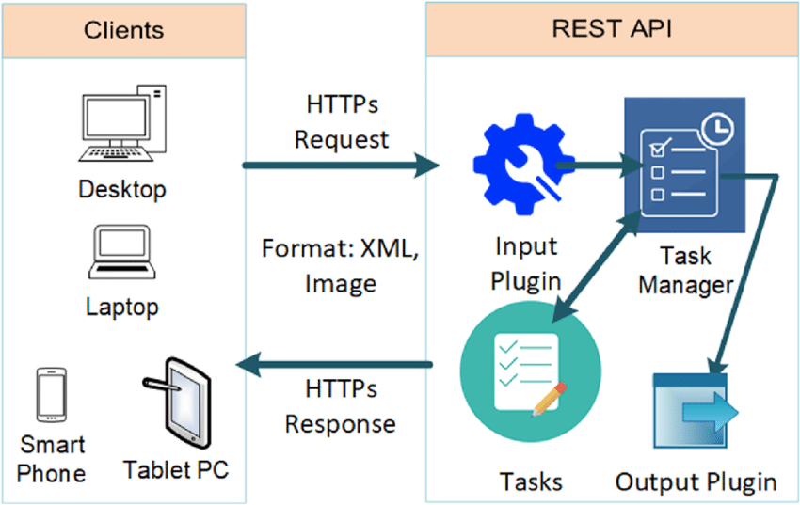Communication between web application components is also a very important part of the application development process. One of the most used interfaces for transferring data bidirectional between software applications are REST APIs (Application Programming Interface). APIs are designed as a bridge that let data travel between two applications. Basically, this is how the backend and frontend the most commonly communicate over the HTTP protocol. The HTTP protocol is the most used protocol for transferring information between a Web Browser and a web server, and it represents a text protocol. The entire communication process is illustrated in Figure 4 - Application Rest API communication [7].

Figure 4 - Application Rest API communication

In terms of technologies, it was a hard decision to be made. For this application several options were available for the client-side also for the server-side.

For choosing a backend technology more factors were taking into count and more frameworks. The first option for this application as a server-side technology was for sure .NET because it is fast, can be deployed on any platform and I am most familiar with it, but it has the disadvantage that you cannot create AI components that easy. The Second option was Java with Spring framework, because it is open to OOP writeable code, it is a fast-learning framework and it is very used worldwide, but as well as .NET it does not provide an easy AI solution. Another option was Python because code is very easy to write, it has support for AI, APIs are very easy to write, but as a weakness, it does not provide a strong typing convention.

In terms of client-side solutions, the following options were considered: Angular because it is a component-based solution, it has some support from ASP.NET Boilerplate and it is the most used web framework with .NET, but it will generate a lot of files in the end; React.Js because of their growth over time and because it uses components and it has some awesome UI kits available, but the disadvantage is that development starts from scratch. Also, I considered using .NET Razor pages because it does not need two projects, it can bind DTOs directly, but it means that classic styling with CSS and JavaScript should be used.

After research, My Vehicle Management (MvManagement) is using the latest version of technologies available for now. This application is designed on top of .Net Core 6 which was released on November 8, 2021, according to Microsoft official website [8], for the backend of the application. In terms of client-side technology MvManagement is using the last version of the React.Js at the moment of writing, one of the most known and used java script framework taking into count the statistic done by Stack Overflow [9]. This statistic shows that React.Js is one of the most preferred and most used web frameworks and it will be clear why after next paragraphs.

## 4.1. Server-side technologies

As mentioned, this project is built on top of one of the most used technologies all over the word. Because .Net is a widely used solution for developing applications, because it is fast, it is maintained by one of the word’s giant companies, Microsoft, allows asynchronous programming. It is a cross platform, allows deploying on any platform not only on Windows; this concept is supported by Microsoft on their website [10]. Last but not least, .Net is an open source that means that everyone can contribute, add their knowledge in order to get the best from this framework. In terms of programming languages, .NET uses C# which is a solution that encourage all the OOP related principles as Encapsulation, Composition, Aggregation, Inheritance, Abstraction and so on.

The version of the .NET was an important decision to be done, and MvManagement application is built on .NET 6 because it is an LTS (Long term support) release, which means that it benefits from Microsoft support for more time. According to the book “C# 10 and .NET 6 – Modern Cross-Platform Development” by Mark J. Price [11] the LTS versions of .NET are supported since a new LTS version is released and Current versions are supported just for a period after a newer version come out.

Driving without rules is impossible and everything will be a disaster, a lot of crashes, standstills and so on. That can be also applied for coding and there are also some rules and principles for writing. One of the most known and relevant rules and best practices for Object-Oriented programming (OOP) are five SOLID Principles. Each letter of the word SOLID names one principle. First principle is the Single Responsibility principle, this principle states that a class should do only one thing. The next principle described is the Open-Closed principle, it states that classes from OOP should be open for extension and closed for modification. This means that code inside classes cannot be modified but the name class can be extended, more functionalities can be added. The third principle, corresponding to letter L, the Liskov Substitution Principle which states that child classes should be substitutable for the parent classes. Next principle, the Interface Segregation Principle is about separating interfaces. The reason why this principle appeared is because a class should not be forced to implement methods that are not required. The last principle, corresponding to letter D, the Dependency Inversion Principle states that classes should depend on Interfaces and abstraction not on concrete classes.

MvManagement is built on top of ASP.NET Boilerplate framework [12] created by Volosoft and maintained by the entire community because it is an open-source framework, moreover, it also benefits from the support of the .NET Foundation. It is a Framework designed on top of SOLID principles that is a very good solution for developing web application with actual practices and tools. What does it provide? ASP.NET Boilerplate (ABP) from my use and according to their documentation it offers a layered architecture based on DDD (Domain Driven Design), modularity, the possibility to build your own modules on top of their modules, multitenancy, a way of storing data about different entities on the same server named by Gartner Glossary [13] and also by the ABP official documentation. In additions, to this awesome programming features, ASP.NET Boilerplate provides a very useful documentation and a prompt, helpful GitHub community. Some common structures provided by ABP are Dependency Injection, session managing, caching, logging and setting management.

Dependency Injection is a software design pattern which aims to separate the declaration of the dependency from the implementation itself. This way by using dependency injection programs manage to be loosely coupled and to follow the dependency inversion and single responsibility principles. In .Net the design of dependency injection is mainly done by creating and interface which contains the structure of the methods, name of the method, returned type, parameters and their type. Interface is implemented by a class or more classes. Further other classes can use the interface methods without knowing how methods are implemented because it is ensured by the interface that the result will be the one expected. Dependency injection is managed inside MvM by ASP.NET Boilerplate framework. It uses the (Castle Windsor [14]), open source, framework for this and some strict naming conventions. By only using Castel Windsor, the dependencies should be mapped manually by declaring Container and then registering each dependency something like:

With the help of the ABP this kind of dependencies are automatically registered. The naming convention is that if there is any class that implements an interface called IVehicleAppService and its name contains VehicleAppService postfix it will be automatically registered as implementing IVehicleAppService. Classes can have other names without following the naming convention and can be registered in dependency injection container, but it must be done manually.

Component.For<IVehicleAppService >().ImplementedBy<VehicleAppService>().LifestyleTransient()

Session is another very important feature provided by ASP.NET Boilerplate. Basically, it provides an interface IAbpSession which can be injected and can be used to obtain information about the current user and tenant without using ASP.NET’s Session according to their documentation [12]. AbpSession defines a few key properties like, UserId which represents the id of the current or it can also be null if there is no current user. TenantId another key property and one of the most used describes the id of the current tenant or null if the current user is not assigned to a tenant.

More, ASP.NET Boilerplate provides background jobs and workers that are executed in the background without affecting the application. They are executed on a separate backgrounded thread. Background workers can be used to create automated running tasks at a set timing period. To create them ASP.NET Boilerplate offers an interface called IBackgroundWorker that can be used as a guide for the required task. As an alternative the classes BackgroundWorkerBase or **PeriodicBackgroundWorkerBase** can be inherited according to their documentation [12]. In order to get background jobs working they should be added to the interface IBackgroundWorkerManager and it is most commonly find in the PostIntitialize method of the module.

## 4.2. Relational Database

In terms of databased MvManagement remains stuck to Microsoft technologies and it uses Microsoft SQL Database. MS SQL represents a relational database. A relational database is a collection of data items with a predefined relation between them. These items are organized in a set of tables with columns and rows. Each table has a strongly defined structure which describe a specific kind of object. Each column states a specific attribute and has a specific type. Each object stored in the table represent a row in that table. Each entry in a relational database table can be unique identified by a property called primary key. The relation between two rows from deferent tables is described by a foreign key.

SQL states for Structured Query Language. SQL is the mediator used to communicate with a database management system. According to ANSI (American National Standards Institute), it is the standard language for relational database management systems. SQL statements are used to perform different action on database, such as updating an entry, creating a new entry, querying a specific table.

In order to get an efficient way of creating, mapping and using database models MSSQL is combined with Entity Framework 6 [15]. According to Microsoft, Entity framework is an ORM (Object Resource Mapping) tool that allows CRUD operations without having to write SQL queries. Entity Framework provides two important ways of creating mapping, code-first and database-first. Code-first approach as the name says states that the first done is the code, this means that entities are designed in code using some tools provided by Entity Framework than migrated to database by using EF-cli (CLI = Command Line Interface). After entities are designed migration is added using “Add-Migration Migration-Name“, then command “Update-database” in order to apply the migration to the database. The second approach, Database-first, means that firstly the database is designed using specific tools or directly from SQL code and then the mappings are done in code. For the MvManagement the method used is code-first because this way some code can be written, tested, the migration added and then the database updated.

## 4.3. Client-side technologies

### 4.3.1. React.JS

For rendering the user interface MvManagement is using React.JS library. This library builds Single-Page application. According to the article “Single-page application vs. multiple-page application” written by Neoteric on medium.com [16] single-page applications are web solutions that do not need re-rendering a page in order to display new content. The biggest advantage of using single-page applications is that all the resources (HTML, CSS, Scripts) are loading once in the app life. Also, this is a component-based JavaScript library, that means it builds component with their unique management context and this results in complex UI.

Single page applications, as React.JS builds, need to have an own mechanism to change how elements are displayed on the page. In React applications, this management is done using states. Basically, every component builds in react uses one or more states and all components are rendered dependently form a state. In order to give the developer, the option to manipulate these states, it provides some special methods called Hooks. This Hooks follow a strict naming convention and all start with the prefix “use”. Some of the most common used hooks are useState, useEffect, useRef. Each of these Hook is used for very specific action. UseState hook is developed to create a local state inside a React component, it provides a getter and a setter for the state created. Another important hook, useEffect, as the name said it react to an effect mainly a state change. If the state is not specified, the actions inside hook take place at component render event. A bit different to the others, useRef hook, provides a way to refer another component and its properties.

An advantage of this library is that it is open-source, and you can easily find support. Facebook from 2021 named Meta, decided to use React as an open to development project from 2013 since now, according to their GitHub release history [17]. Now is one of the most used and preferred web framework by developers taking into count the study done by Stack Overflow [9].

In addition to React.JS for this application uses an UI kit named Chakra UI [18]. This UI library was relatively recent released, in 2020, and is very popular among developers because is easy to use and is lined up with react actual standards. Chakra is offering a way of writing fewer and cleaner code, but also let developers extend component to get the best from them.

Components represent the most useful part of using an UI kit and Chakra is providing a lot of them. According to their website at the moment of writing they are offering components from 11 different categories. A few of them had an important role in choosing Chakra UI, layout components that are designed to keep your website appealing on all screen sizes, no meter if people are using it from the phone or from a desktop. Another category of components that have a very important role for the aspect of the website is Form components category. Forms components provided by this UI kit are appreciated because they are offering nice looking buttons which can be easily can be customizable. Moreover, it provides already design inputs on top of which developer can add its signature in order to make it looking good. There is more other small component have a great impact to your website as Breadcrumbs, Icons, Alerts, Tooltips and so on.

Installing UI kits can sometimes be very annoying, and you must read a lot of rigid documentations. For Chakra UI this is not the case. Installing it is as easy as wrapping the application tag in a “ChakraProvide” tag. This feature was very appreciated by the developer community.

### 4.3.2. Redux

React.JS applications by construction are based on states. This JavaScript framework manage states. State management is generally handled locally for each component value. For managing states that are meant to have a global role, using the Redux library is the way to go. Based on their website Redux is a predicate state container for JavaScript Apps [19]. Redux team recommend using Redux together with Redux-Toolkit. Redux has three very important components, the redux store, states and reducers. Redux is using the global store that is defined at application start. The root Redux state represents the main state of the app and it stores the applications states further. Based on Redux documentation application states are always stored as plain JavaScript objects and arrays. This mean that any custom classes instances or build-in JS types like Map, Set, Promise, Date, functions that is not plain data is not allowed. Next to describe components are Reducers. Reducers are functions based on a state and an action that returns new states. Actions are new introduced here. This as the states are plain JavaScript objects that have type as an attribute. Any extra data needed to describe what is happening is put inside payload attribute.

Together with the React-Redux library accessing states and reducers are easier to use and code is cleaner. This library designed for React.JS brings two very important hooks, useSelector and useDispatch. First one, useSelector, is intuitive because it offers access to the state stored in Redux. The second one, useDispatch, has the role to give control to the reducers.

# 5. Application

## 5.1. Application structure and deployment schema

My Vehicle Management application has four main parts. Server-side which represents a .NET Application that covers the application logic. The server side is strongly coupled with the SQL database which represents the second part. The third part is the OCR application designed in a FastAPI REST Services application using Python and Tesseract. All of this are collected and offered to user in the client-side. The client-side is a React.JS application that consumes the endpoints from backend and OCR application.

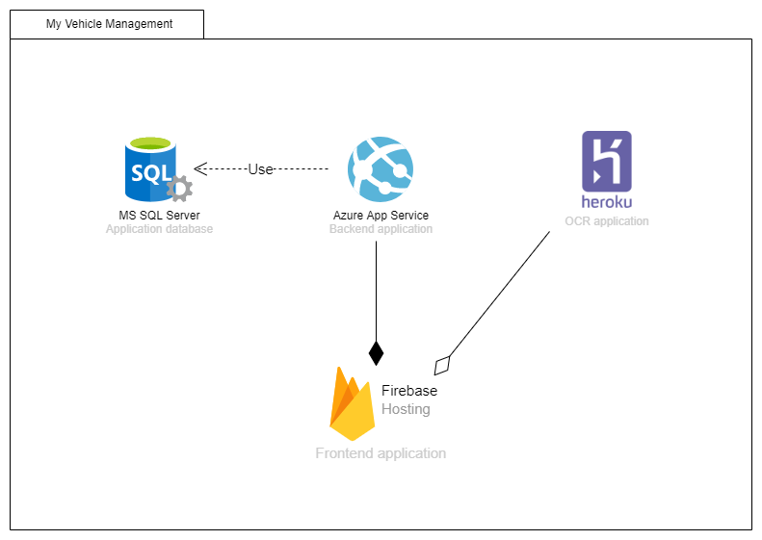Many technologies being involved means many places to host. The application environment is hosted on 3 different platforms. This is the best solution found in terms of performance and costs. For backend application the option to go is Azure App service. It is also an advantage that both .Net and Azure are maintained by the same company, Microsoft. For MS SQL database the best hosting solution comes also from Microsoft, namely SQL database basic plan from Azure. Cost, performance and fast deploying option make Firebase hosting the best solution for the React.JS frontend application. Last but not least, the OCR application, a python developed app fits best on Heroku hosting. A clear vision about deployment schema is shown in Figure 5 - Deployment diagram.

Figure 5 - Deployment diagram

## 5.2. Optical Character Recognition (OCR)

Reading text from image covers more than just recognizing characters. To have an accurate result preprocessing is necessary. After preprocessing, comes into place the text recognition itself using the existing engines, free or paid. Then the last step in transforming text inserted in image into a computer useable text is postprocessing. These all steps are required for an efficient OCR process. For achieving the text extraction, we chose to use Python together with some external libraries. The libraries used are FastApi for creating endpoints, OpenCV for image processing, numpy for boxing image, and Tesseract python library for extracting the data.

### 5.2.1. Preprocessing

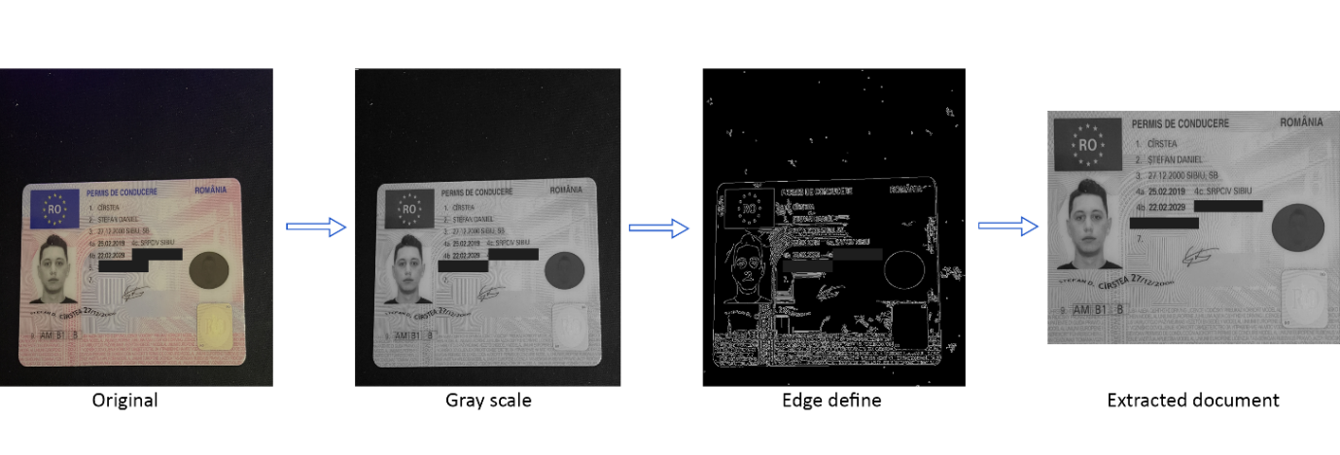Preprocessing is the most complex step of OCR process. For the case described, in this application the preprocessing steps are resizing the original image, gray scaling, removing the imperfections and not needed lines and extracting the paper or document from the original image. Figure 6 shows the original image after resizing, the end result and the steps between.

Figure 6 - Image processing steps for driving license

First step in preprocessing the image for scanning the driving license is to resize the image, in this case the image was resized to 900 pixels width and 1600px height assuming that the image was done in portrait mode. Next step is removing the colors from the image because the OCR engines recognize dark text highlighted on white paper and doing this the OpenCV library was used, namely the cvtColor method. Another OpenCV method needed for performing the line detection, it is called Canny and the result is the one in Edge define image from Figure 6. In this step we also added a gaussian blur effect to image in order to remove the fine line from the driving license card. The last step on preprocessing level is capturing the driving license card, in this case. This extraction was also done using OpenCV methods.

### 5.2.2. Text extraction

After the image preparation it can be accurate extracted by the OCR engine. The one chosen for performing this step involved the Tesseract OCR. Because the recognition set up was done for a Romanian document the option for the Tesseract language is Romanian. Another configuration option chose for Tesseract OCR engine is to set it up on automatic page segmentation, this is because image even with preprocessing can have some imperfections.

### 5.2.3. Postprocessing

After the text is successfully extracted from image it is time for the preparation in order to be delivered to the end user. For a clear vision about how the data is structured the elements were transformed in a python dictionary. The dictionary components are last name, first name, date from when the license is available and the date when the license expires. Because the text is extracted as a page, that means it will have the same structure as in the original document. In the best case, when all characters are recognized correctly, the end result of the OCR process will look like in Figure 7.

Figure 7 - Extracted text for a Romanian driving license

To format the text into a Python dictionary, the text needs to be sliced by type. This way the post processing is designed to split the text received after OCR by lines first. Then for each line the words are extracted. For name extraction pattern, the first word is ignored and the others are marked as first name, respectively last name. Another pattern for this case is the one for lines containing date. Lines are divided by words, the first word is again ignored and the next is considered to be a date. After date extraction, the word containing date follows a recognition process. The recognition process represents a regex for the date that should match in the extracted word. If the recognition process does not match at first try, a replace is performed in order to replace the commas with a dot because it is a very common mistake the OCR engine makes on parsing the text.

### 5.2.4. Exposing

For creating a really usable feature the OCR should be accessed remotely. The solution for this issue is to create an endpoint which receives an image and then triggers all the OCR parsing steps. The API was created using the FastAPI python library. Exposing endpoints through the internet means that anyone can access it and you need to secure your endpoint to be sure that just the allowed one can access the endpoint. In this case the text extraction endpoint was restricted by the DNS. This restriction was done using an allow CORS origins restriction. This Allow CORS origins means that just the whitelisted origins can access the endpoint. In this case the case the whitelisted server is just the frontend server which consumes the resource.

## 5.3. Server-side

### 5.3.1. Structure

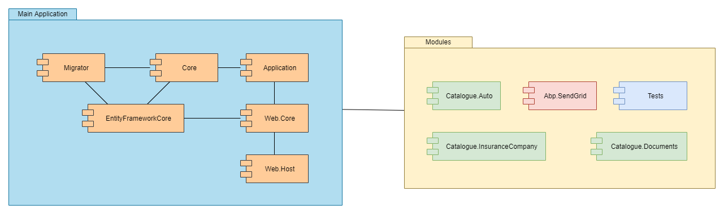Server side or the kernel of the application has a multi-module and multi-project structure, where each module and project have its role. The main application has as component six projects, namely, Application, Core, EntityFrameworkCore, Migrator, Web.Core and Web.Host and this projects also have reference between them. Except from the main application, there are other decoupled modules. There is a module for catalogues containing auto related catalogue project, documents related catalogue project and insurance companies related catalogue. Another module contains the Abp.SendGrid module for SendGrid mail provider. And the module that ensure us that backend is working as we expect is the tests module. The backend application structure is also described in Figure 8 and offers a clearer vision about the above-described projects and how they are linked one to each other.

Figure 8 - Backend application projects structure

As previously mentioned, each project from backend application has its own scope and role. Entity Framework (EF) is used in the application through the EntityFrameworkCore project. That means that this project represents our middleware to communicate with the SQL database. Because the applications are designed on a code-first approach for EF the migrations added through EF should be reflected also in database. The project responsible for keeping the database up to date and to apply EF migrations is the Migrator project. An important project is the Core project, it stores the business logic, entities, helpers, extensions, authorization, and other data that should not be exposed to consumer. Application project is the biggest Core project consumer and is strongly dependent of it. This project stores the application services, DTOs (Data Transfer Objects) and all the logic that is meant to serve the consumer needs. A very important project is the Web.Host one, because it represents the communication with the end consumer of the APIs. Representing the communication middle with the consumer the Web.Host project main role is to store the endpoints definition. Another middleware project is the Web.Core which as expected represent the mediator between controllers from Web.Host and the application services from the Application project.

### 5.3.2. Authentication & Authorization

In order to keep user information safe and secured, the server-side application is designed to expose information only if the user is authenticated in the application. For this application authentication is done using JwtBearer authentication which generates and validation token using the endpoint “/api/TokenAuth/Authenticate” that provides user access to secured endpoints. This token is unique and user specific and is randomly generated based on security key. The secured endpoints are marked using Authorized annotation.

There are also some endpoints that are meant to be used only if the user has a specific authorization, for example to see the organization users. This is done using permission and roles. Endpoints that need specific permission to be used this are marked with an annotation as in Figure 9. This authorization can be applied also for classes and the effect is applied for A screenshot of a computer
all exposed methods inside class.

Figure 9 - Permission authorization for endpoints

This token is used as user signature, because based on this token we obtain the current logged in user or whether the user is authenticated. Based on this token we have the certitude that we can provide user information about his account because it is certain that is his account.

Excepting the endpoint permission itself, in application there are also some vehicle specific permission implemented, which are described in the next chapter.

### 5.3.3. Vehicle permission

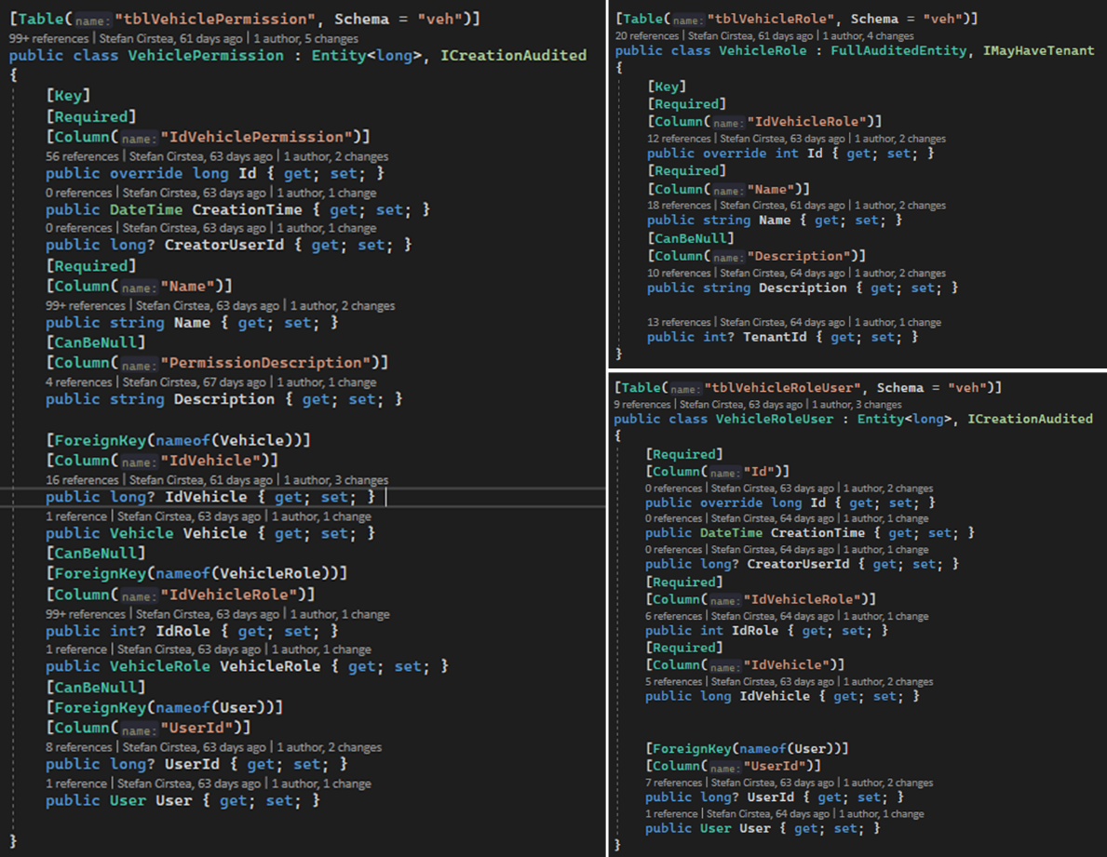The part that makes the backend of the application different is that the app is designed for both companies and individuals. This is because companies have the option to have custom roles, both for company entity inside application and for one vehicle itself. For example, a transport company has many drivers. In this case, as a company owner you want drivers to be aware if the vehicle, they are driving has an insurance or technical inspection that is about to expire.

Figure 10 - VehiclePermission, VehicleRole and VehicleRoleUser entities

Vehicle permission management feature is based on three important entities, VehiclePermission, VehicleRole and VehicleRoleUser. VehicleRole represents the roles that are defined and can be assigned to a person referencing a vehicle. VehicleRoleUser is the linker entity and contains information about what role, on which vehicle the user has. Finally, the VehiclePermission entity, which is more complex, represent the permission itself with its description and can be assigned both for role and for individual user. These entities are illustrated in Figure 10.

The extended classes are provided by ASP.Net boilerplate. Entity class ensures that the class that inherit it has the Id property to be transformed in a database table. FullAuditedEntity also implements the Entity class, but it also has some specific properties. This class provides some properties that keep track of creation time, creator user id, last modification time, deletion time and more that are automatically handled by ASP.Net Boilerplate at runtime. Moreover, this class offers the soft delete option. Soft delete is basically a column named IsDeleted, if its value is positive than the database entry is ignored.

As an aside, it is important to point out that Figure 10 shows how Entity Framework code first approach is implemented. The idea is that mainly the database models are creating by using annotations. Table annotation is mandatory for Entity Framework to what is the name of the creating table and optionally the schema can be added as in the case showed. Key annotation is used to mention that the property is a primary key in the future table. The consequence of Required annotation is that the property will have a constraint and it can not have the null value in the database. The opposite of the Required annotation is CanBeNull which allows the null value for the specific attribute. Giving other name than the C# attribute name to the database column can be done by using Column annotation on the attribute. The link in the database is done by creating foreign keys, in order to create a foreign key with Entity Framework the ForeignKey annotation is used and as parameter the name of the associated property is passed.

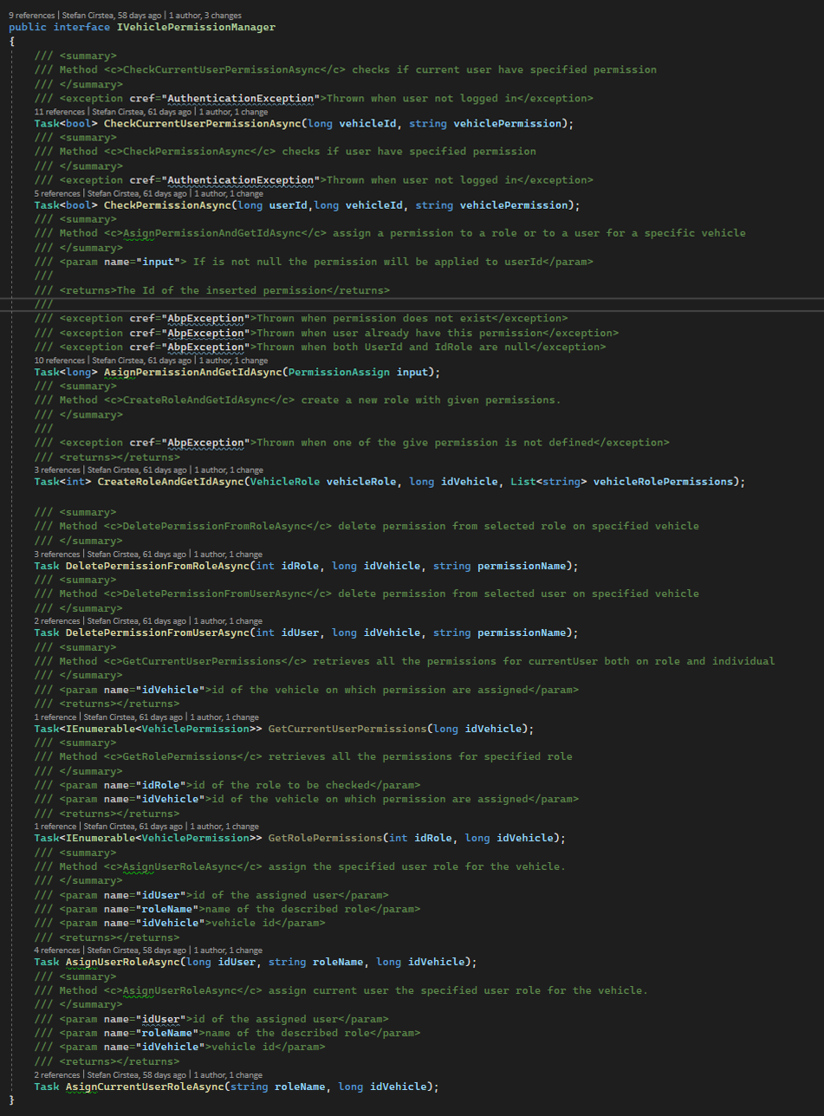Back to vehicle permission, to use this permission in application services a custom manager was designed. This custom vehicle manager has also an interface that is implemented by the manager. This interface is showed in the Figure 11, and it is injected using dependency injection into application services that needs access to vehicle permission.

Figure 11 - Vehicle permission manager interface

Figure 11 also describes the methods provided by the interface and their signature. These methods signature also have its proper documentation, which scope is to help the programmer use them. Vehicle permission manager provides method for: check if the user has a permission, assign permission to user and to specific role, create role, remove permission from user and from specific role, retrieve all user’s permission for specific vehicle, retrieve role permission and assign user to a role.

This method implementation as the other implementations from application are done using the repository interfaces provided by Entity Framework and LINQ expressions for queries. One of the most used methods, CheckPermissionAsync is shown in Figure 12.

Figure 12 - Method implementation for checking user permission

This method implementation is somehow tree structured. This tree structuring comes from the fact that firstly is checked if there is any role assigned to the user. After the role check follows the permission check. The permission check depending on the role check result is searched by user individually or for both the role assigned to user and the user himself. Then for simplicity in this implementation the method is also used in CheckCurrentUserPermissionAsync which basically has the same scope, but it checks the permission for the logged in user.

## 5.4. Client-side

### 5.4.1. Structure

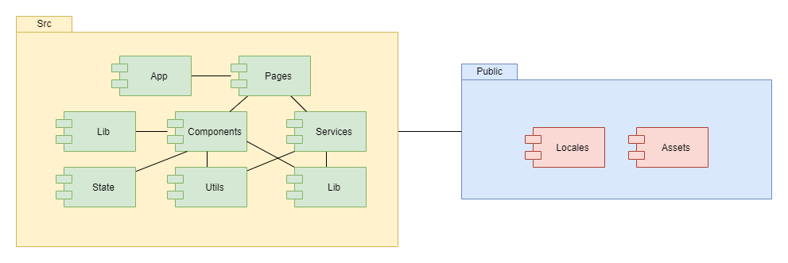Visual part of the application as the backend part is structured in modules and basically each folder from root represents a module. There are two root modules, namely public and src, and each of them is tiled in sub-modules. Public contains data that is public, like localization module and assets. And the src module contain more sub-modules that are used in creating the application interface. The structure and containing modules are described in Figure 13.

Figure 13 - Client-side application modules structure

Each sub-module has its own scope. App module is used to store the general application related features as the custom styling and routing. In components module are stored the custom-made elements that are next used in pages. Intuitive, pages module stores the pages components. In the lib module covers the constants and application logic files that are needed in more than one component farther. Utils module stores the utility components as localization configuration and custom hooks. State module is reserved for redux components, namely slices, thunks and store. The linker module between frontend and backend is the services module.

### 5.4.2. Authentication context

React.JS is based on states, but states have sense only inside a component and at re-render the state comes back to its default value. Sometimes, managing states globally, in entire application is needed and that is achieved using Redux. One scenario for using Redux is for managing the authentication status and current logged in user. User state stored using redux is composed of authentication status, current user object retrieved from backend, tenant (company) information also received from backend on authentication, user permission inside application and loading status. For accessing the application user over application and for creating custom rendering based on authentication status a custom context is defined that wrap the application component. Figure 14 - AuthProvider implementation and usage shows in the right side how AuthProvider component is used and its implementation in the 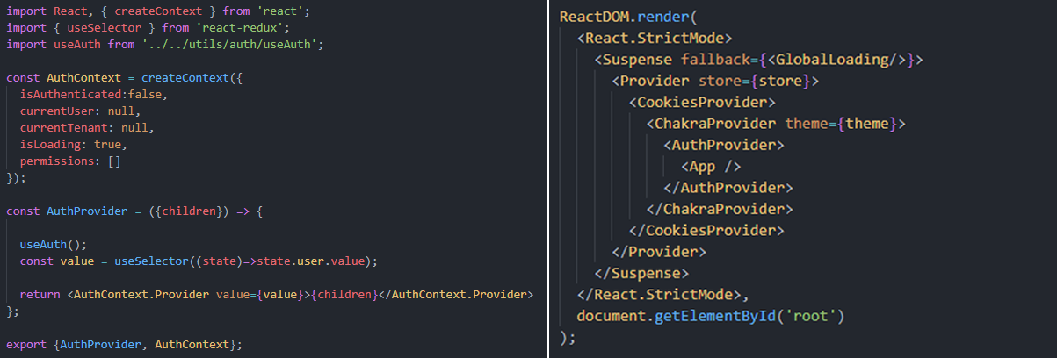left side.

Figure 14 - AuthProvider implementation and usage

Context implementation uses also a custom defined hook named useAuth which scope is to check session status and to set the Redux state. Inside provider the value for user state is retrieved using useSelector hook and the value is set to context provider. Setting the user state value is done using useDispatch hook. Custom, useAuth hook implementation is showed in Figure 15.

Figure 15 - useAuth custom hook implementation

Because the AuthProvider wrap the application component the authentication context can be used everywhere inside application component and its child components. Accessing the AuthContext is done by using useContext hook.

## 5.5. Database structure

Figure - Database table diagram for dbo schema

****Application persistence is ensured by a relational database, namely Microsoft SQL Database. As the name said this kind of database is defined by relations. Application database is quite complex in terms of relations. Database diagram is present in Figure 16, Figure 17 and Figure 18, it covers all types of relations between two tables.

Figure 17 – Database table diagram for doc schema



Figure 18 - Database table diagram for veh schema

For a clear workflow, database is designed to have different schemas for different application zones. That means that for application related tables the schema used is dbo and can be seen in Figure 16, the default one, for vehicle related tables the schema chosen is the veh presented in Figure 18 one and another schema, named doc, is used for document data storage, last one is showed in Figure 17.

## 5.6. User manual

My vehicle management is a web application that is designed to keep track of your vehicle related documents. Besides the vehicle document management feature the application offers information about refuels and the possibility to scan your documents and automatically extract the data from it. MvManagement application users are always aware if their documents are about to expire. The application check for them, daily, and announce them per e-mail if there is any document that is about to expire within a week.

Access to application is free, interested persons just need to create an account and can benefit of all MvManagement features. Application opens on login screen, in order to create your account, new user has to click on “Register” and fill out the form with the requested data.

Once logged in, user has access to fuel cost for his vehicles, cost per vehicle graphic and if exists he is warned that he has documents which need some attention. The dashboard design is showed in Figure 19.

Figure 19 - My Vehicle Management application dashboard

Figure 19 represents the first place where the authenticated layout appears. This layout is meant to have some application important features that can be seen everywhere in the application. The first important feature available from the entire application is language change. In this moment, application supports two languages, English and Romanian. Second feature available from entire applications is color theme changing button, this feature allows the user to choose if wants the application design in dark or light mode. Both features can always be found on the upper right corner of the application. Once authenticated in application, there are two more features available in application layout. The most used, the navigation menu, the menu is located on left side of the application and contains navigations link to application features. Menu is built from home page or dashboard, user documents where the user related documents can be found and vehicles where user’s garage can be found. The second feature available anytime when logged in is the settings feature. Accessing account settings in not something that users do every time, this way in order to access it, feature is intuitive placed under the user logo.

Back to dashboard available features, the most used one is displayed under the title “My Garage”. This feature provides user access to add a vehicle to his garage by clicking the plus button, edit vehicle information or even remove a vehicle from garage. This garage representation also offers a way of seeing more details about the vehicle by clicking the eye icon available on each table row.

Once the user accesses the vehicle page, MvManagement application provides statistics and detailed information about the vehicle. This way information related to vehicle insurance, refills or periodical document as technical inspection are showed. Vehicle page and its related features are showed in Figure 20.

Figure 20 - Vehicle page inside MvManagement application

Another important feature is user’s documents management. This one can be accessed by clicking the “User documents” option from left side menu. User documents page ca be seen in Figure 21. On this page, the document text extraction is already implemented. When the user wants to add a document, he is encouraged to add the document picture, this is showed in Figure 22. If the users chose to upload an image with their document the OCR algorithm is access through an API request and then after the processing the extracted data is filled in the form fields. Then, after checking that the extracted data is correct, the user can save the document by clicking the save button.

Figure 21 - User documents management page

Figure 22 - Add user document modal & OCR feature

# 6. Final words

To keep track of everything is not easy, especially when daily activities cover your entire day. My Vehicle Management application now is designed to be user’s vehicle assistant. Application was built for people whose time is very important and the aim of it was to offer user the possibility of uploading a photo of their document and our OCR algorithm to extract the data for them. Besides this OCR feature, MvManagement also offers their users other helpful features as remainders of the expirations date of documents and the possibility of fuel consumption tracking. MvManagement can be considered a secretary for your vehicle. You give the application access to documents which contain information and then the application extract the relevant information from them. More, as a good assistant reach out to you when documents need your attention, and it also provides you some statistics about your vehicle to keep user aware.

From a company perspective MvManagement is designed to offer the company’s managers a fleet management environment that can be accessed by their employers and each of them having a specific role access.

My Vehicle Management does not represent a final product. This application looks forward coming with OCR integration for most common documents, vehicle and user related. To achieve more research and documentation is needed before starting the actual work. We plan based on the traffic and the most added documents to create a statistic that will help prioritizing one or another document type. Another feature that is planned to be available in the application is service management, this is meant to keep track of your vehicles service history and upcoming periodical mandatory changes. Plans also contain a feature that users will not be that happy to use, but it is very useful to have, this is an incident report feature. This feature will allow the user to create the settlement agreement or in romanian named “Constatare Amiabilă”. The application will give you all the needed information and will guide you to all the steps to reach to an agreement and fill in the form.

# 7. References

|  |  |  |
| --- | --- | --- |
| [1] |  | Movcar SRL, MOVCAR Website, 2021. [Online]. Available: https://movcar.app/. |
| [2] |  | PaddlePaddle, PaddleOCR, [Online]. Available: https://github.com/PaddlePaddle/PaddleOCR. |
| [3] |  | A. Rosebrock, OCR with OpenCV, Tesseract, and Python, 2020. |
| [4] |  | M. A. Lee, Matthias A Lee, [Online]. Available: https://matthiaslee.com/. |
| [5] |  | OpenCV, [Online]. Available: https://opencv.org/. |
| [6] |  | FastAPI, [Online]. Available: https://fastapi.tiangolo.com/. |
| [7] |  | REST-API-Comunication Figure, [Online]. Available: https://www.researchgate.net/figure/The-REST-API-communication_fig3_355708737. |
| [8] |  | .NET and .NET Core Support Policy, Microsoft, 2021. [Online]. Available: https://dotnet.microsoft.com/en-us/platform/support/policy/dotnet-core. |
| [9] |  | "Stack Overflow insights," Stack Overflow, 2021. [Online]. Available: https://insights.stackoverflow.com/survey/2021#most-popular-technologies-webframe. |
| [10] |  | Microsoft - What is .NET?, Microsoft, [Online]. Available: https://dotnet.microsoft.com/en-us/learn/dotnet/what-is-dotnet. |
| [11] |  | M. J. Price, C# 10 and .NET 6 – Modern Cross-Platform Development, Packt Publishing Ltd., 2021. |
| [12] |  | ASP.NET Boilerplate, Volo Soft, [Online]. Available: https://aspnetboilerplate.com/. |
| [13] |  | Gartner Glossary - Multitenancy, [Online]. Available: https://www.gartner.com/en/information-technology/glossary/multitenancy. |
| [14] |  | C. Project, Windsor, [Online]. Available: https://github.com/castleproject/Windsor/blob/master/docs/README.md. |
| [15] |  | Entity Framework 6, [Online]. Available: https://entityframework.net/. |
| [16] |  | Neoteric, Mediu.com - Single-page application vs. multiple-page application, [Online]. Available: https://medium.com/@NeotericEU/single-page-application-vs-multiple-page-application-2591588efe58. |
| [17] |  | Facebook, React repository, Meta, [Online]. Available: https://github.com/facebook/react/releases. |
| [18] |  | Chakra UI, [Online]. Available: https://chakra-ui.com/. |
| [19] |  | Redux.JS, p. https://redux.js.org/. |
| [20] |  | PaddleOCR, PaddleOCR - Exemple, [Online]. Available: https://github.com/PaddlePaddle/PaddleOCR/blob/release/2.5/doc/imgs_results/multi_lang/img_01.jpg. |